Pump Controller

# Description

A device which can monitor and switch household water pumps remotely.

V4 changes:

|  |  |  |  |
| --- | --- | --- | --- |
| Change | Criticality | Status | Version |
| Add biasing resistors. | Critical | Done | 4 |
| Design custom enclosure | Important | Waiting for PCB | 4 |
| Replace the wireless module with one supporting Matter. | Optional | Matter modules are not yet available. To be done in V5 | 4 |
| Spring clamp terminals are replaced with screw terminals. | Critical | Done | 4 |
| Pressure sensor JST connector is replaced with screw terminals | Critical | Done | 4 |
| UART JST connector is replaced with a 2x5 pins 2.54mm footprint for use with a test clamp. | Important | Done | 4 |
| TC2050 footprint is replaced with a 1x4 USB footprint for use with a test clamp. | Important | Done | 4 |
| AC/DC module is replaced with a more integrated module. (HLK-PM01 or HLK-5M05) | Critical | Done | 4 |
| Test points are through hole. | Important | Done | 4 |
| Add LEDs to DC supplies. | Important | Done, | 4 |
| Add connectors for chassis mounted LEDs and buttons. | Important | Done, one LED light | 4 |
| Remove AC-DC converter and rely on external 12V power adaptor | Important |  | 5 |
| Use DC-DC converter for 3.3V |  |  |  |
| Use 12V version of the relay |  |  |  |

# Constraints

Power: 12V wall power adaptor

# Features

* Monitor the on/off status and current consumption
* Switch the pump off if desired.
* Indicate if the pump is running dry.
* Wireless connectivity
* Matter optional

# Block Diagram

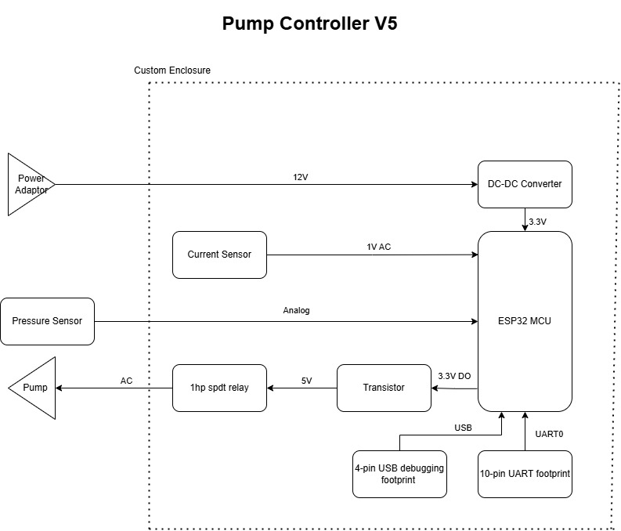

# Future Improvements

# Components

MCU: ESP32-C3-WROOM-02-N4,

## AC/DC Power Supply:

|  |  |  |
| --- | --- | --- |
| Criteria | HLK-PM01 | HLK-5M05 |
| Price | $2.0886 | $2.4431 |
| Package | 34*20*15 | 38*23*18 |
| Manufacturer | Hi-Link | Hi-Link |
| Current | 0.6A | 1A |
| Input Voltage | 100-240 | 100-240 |
|  |  |  |
|  |  |  |

Fuse Holder: 56000001019 or 56000001009

Fuse: 39212000000 or 0034.6618

MOV: MOV-10D561KTR

Common Mode Choke:

Safety Capacitor: B43821F5226M000

CY: CL31B102KHFNFNE

Output Cap: A750EQ477M1CAAE015

Output inductor: LSXBD6060WHL4R7M

Output Cap 2: ESL107M035AE3AA

TVS: SMBJ7.0CA-13-F

CAP 3: CL10B105KO8NNNC

## 3.3V LDO: AP2112K-3.3TRG1

Zmct102 (pcb mount)

Terminals: WJ142V-5.08-2P

JST Connector: B3B-XH-2(LF)(SN)

Pressure Sensor: Seeed 114991178 or equivalent.

Terminal Block: XY118-5.0-2P

ADC?

Relay: J115F21C5VDCS_9 or az2100-1ce-5def or SLC-5VDC-SL-C

Flyback Diode: 1N4007FL

Transistor: DMG2302U-7

Box: 10x10cm CCTV box

# Power Budget

|  |  |  |  |  |
| --- | --- | --- | --- | --- |
| Component | Voltage/s | Current/s | Power | Type |
| PBO-5C-5 | 5V | 1A | 5W | Source |
| AP2112K-3.3TRG1 | 3.3V | 0.6A | 1.98 | Source |
| ESP32-C3-WROOM-02U-N4 | 3.3V | 0.35A | 1.15W | Sink |
| 114991178 | 5 | 0.01 | 0.05W | Sink |
| J115F31CH5VDCS61.5U | 5 | 0.3 | 1.5W | Sink |
|  |  |  |  |  |
| Total | 1.3W | | |  |

*Some ICs have multiple voltage rails with different voltage levels.